You can find some FREE radon related images to use here: https://pixabay.com/users/takeactiononradon-18149510/

What is radon?
Radon is a radioactive gas that comes from uranium naturally present in the soil in Canada. Since radon is a gas, it can move freely through the ground and can enter any building that is in contact with the ground. Radon is present all across Canada, including on the territory of [Municipality name].
Being exposed to high levels of radon gas today makes us more likely to develop lung cancer in years to come. Health Canada recommends that all homes should be tested for radon and take action to reduce their radon levels if required.
Is radon a concern in [Municipality name]?
Yes! Health Canada has measured radon all across Canada and found that no area of the country is radon free. While radon is more prevalent in certain regions, high levels of radon can be found in homes anywhere. It’s even possible for neighbouring homes to have very different radon levels. This is why it’s so important for all residents to test their homes.
How do I test my home?
Testing for radon is straightforward, but it is important to use an approved test kit and follow the instructions. Test kits cost approximately $60 (which includes the shipping and lab analysis fees) and can be purchased online and shipped directly to you. To find a list of retailers, click here: https://takeactiononradon.ca/test-for-radon/radon-test-kits/#buykit
You may also consult a radon professional to test your home. Click here to find a list of radon professionals near you: https://c-nrpp.ca/find-a-professional/
What happens if my home tests high for radon?
If a home tests high for radon, it can be fixed. However, not every contractor is trained and qualified in radon mitigation, so it’s important to consult a certified C-NRPP Professional. Click here to find a list of trained certified professionals in your region who will design a radon mitigation system specific to the home.: https://c-nrpp.ca/find-a-professional/
With a properly installed Radon Mitigation System, even homes with very high radon levels can be reduced to well below the Canadian guideline level.

Building Codes in our Community
Building a new home? Your home has measures to help with controlling radon. [Add specifics for the region].

How do we know RADON is a health issue?
Research in miners (especially uranium miners) first alerted researchers to radon as a health concern, but subsequent research in homes confirmed that radon wasn’t just an occupational hazard for miners. The elevated radon levels that can be found in homes also have a serious impact on our health.
Radon releases radioactive energy which can alter the DNA in lung cells, leading to lung cancer.
The relationship between radon and lung cancer is linear, which means that as the radon exposure increases (exposure = radon level x time) the risk also increases.
The combination of high radon levels and smoking greatly increases the overall risk of developing lung cancer.
Smokers who are exposed to high radon have a 1 in 3 risk of lung cancer.

Smokers who are exposed to low radon have a 1 in 20 risk of lung cancer.

Let’s start with some of the most common radon control and radon mitigation systems, to help you understand what they are and how they work.
Radon Mitigation System
RESEARCH:
Health Canada has conducted research to confirm that a radon mitigation system is the most effective method of reducing radon levels.
HIRING a certified professional LOWERS RADON BY UP TO 90%
INCREASING home ventilation LOWERS RADON BY 25-50%
SEALING cracks LOWERS RADON BY AN AVERAGE 13%

A radon mitigation system is the most effective method to reduce radon levels in a home. It can be called by many names, but we want to focus on what it does.
Radon is a radioactive gas which comes from the ground into a home through contact with the soil.
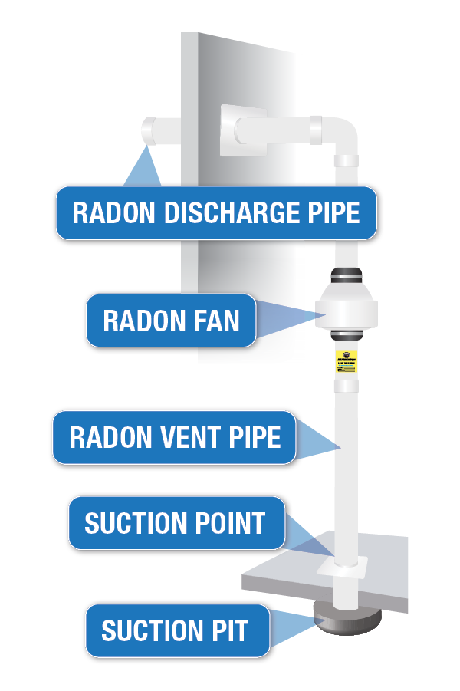
A radon mitigation system provides a pathway for the gas to reach the outdoor air without entering the home.
Using a fan, a radon mitigation system creates an active pathway for radon, as well as moisture and other soil gases, to move directly from beneath the slab of the house to the outside air without entering the building.
Additional Benefits: Homeowners often find that once a radon mitigation system has been installed, their use of dehumidifiers reduces, smells are gone and the air quality is better. This is because a radon mitigation system is effective in removing other substances and moisture that had been entering the home from the soil in addition to radon.
RESEARCH:
Health Canada has conducted research to confirm that when a radon pipe exits the building, the radon quickly disperses leaving radon levels very low in the outside air.

Radon Control in New Homes:

In Manitoba, the building code states that new homes must have a radon rough-in system. What do homeowners need to know? First off, the radon rough-in does not reduce radon; it’s simply the beginning of a system. The rough-in is included in new construction to make it easier and more cost effective to install a radon mitigation system should one be required.
Radon Rough-in:
Purpose is make it easier and more cost effective to install a radon mitigation system should one be required.
Homeowners need to test their home for radon and then decide if the radon rough-in needs to be finished into a Radon Mitigation System.

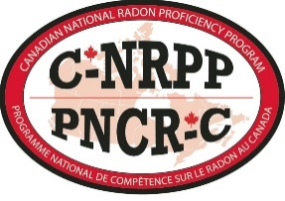
C-NRPP is Canada’s national certification program for Radon Professionals:
Health Canada and CARST (the Canadian Association of Radon Scientists & Technologists) developed the certification program so that building owners had someone to help with testing and reducing radon levels.
To find a certified professional, head to: www.c-nrpp.ca/find-a-professional
Radon Measurement Professionals will help with testing a building for radon.
Radon Mitigation Professionals will help with fixing a building’s high radon.

A certified radon professional provides you with an impartial third-party to give you reliable advice.

Where can I go for more information?
Health Canada Publications:
Radon - What you need to know,
http://www.hc-sc.gc.ca/ewh-semt/pubs/contaminants/radon/index-eng.php

Radon Reduction Guide for Canadians,
http://www.hc-sc.gc.ca/ewh-semt/pubs/radiation/radon_canadians-canadiens/index-eng.php

Lung Association - https://www.lung.ca/lung-health/air-quality/indoor-air-quality/radon
Canadian Cancer Society- http://www.cancer.ca/en/prevention-and-screening/reduce-cancer-risk/make-informed-decisions/know-your-environment/test-your-home-for-radon/?region=on
CARST – www.carst.ca/real-estate
C-NRPP – www.c-nrpp.ca
Take Action on Radon – www.takeactiononradon.ca
Canadian Real Estate Association - https://www.crea.ca/wp-content/uploads/2016/02/A_Homeowners_Guide_to_Radon_CREA.pdf

